Media Alert

OSN ups its content for families

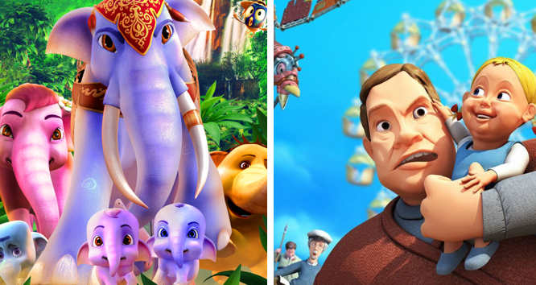

Dubai, UAE – 13 April 2020: OSN, the region’s leading entertainment network is excited to announce that customers can now watch OSN Kids at no extra cost. With over 40 must-see movies to choose from – OSN promises to offer families hours and hours of entertainment from the comfort of their own home.

Available to all OSN customers, OSN Kids offers a mix of exclusive family-friendly content from leading studio partners such as The Walt Disney Company. To access OSN Kids, all families need to do is kick back and tune into channel 15 and enjoy a host of jam-packed content. From family entertainment and educational shows to something to keep the kid’s engaged while they’re at home – anyone will be spoilt for choice. And for former customers who still have an OSN box, all they need to do is plug it in and select the Nilesat Satellite and sit back and relax.

Emad Morcos, Chief Content Officer of OSN said: “To champion our youngest TV fans, we are pleased to offer OSN Kids at no extra cost to our customers. Not only is the channel safe but it entertains and educates children across all age groups. With families now spending more time at home, we hope this will bring them hours of entertainment to be enjoyed together.”

Movie highlights include:

- Back to the Sea
- Ploddy the Police Car
- Operation Arctic
- Nur And The Dragon Temple
- Legen of the Sea
- Victor and the Secret of Crocodile Mansion
- Zodiac: The Race Begins
- Pacific Pirares Bunny Tales
- Help and Freedom
- Ivan the Incredible
- Mia and the Migoo
- Kurt Turns Evil
- Doctor Proctor Bubble in the Bathtub
- Farm friends
- The Emperor's Secret
- The Apple & The Worm
- Marvin Airlines
- The Blue Elephant 2
- Cop Dog
- Cher Ami
- Catcher: Cat City 2
- Ploddy the Police Car on the Case
- Marco Macaco
- Last Wizard
- Ho Ho Animals
- The Wish Fish
- Twigson Ties The Knot
- Memory Loss
- Krazzy Planet
- The Great Bear
- Hocus Pocus Alfie Atkins
- The Secret of Kells
- The Wheelers
- Honey Honey Bear
- Bamse and the Thief City
- Smitty
- Black Sheep Smile
- Amila's Secret
- Funny Little Cars
- The Fairy Tales Tree
- Boonie Bears & The Hunters
- Micropolis
- Quest for a Heart
- Twigson In Trouble
- Mamma Moo and the Crow

